Essential Oil Extractor User Manual

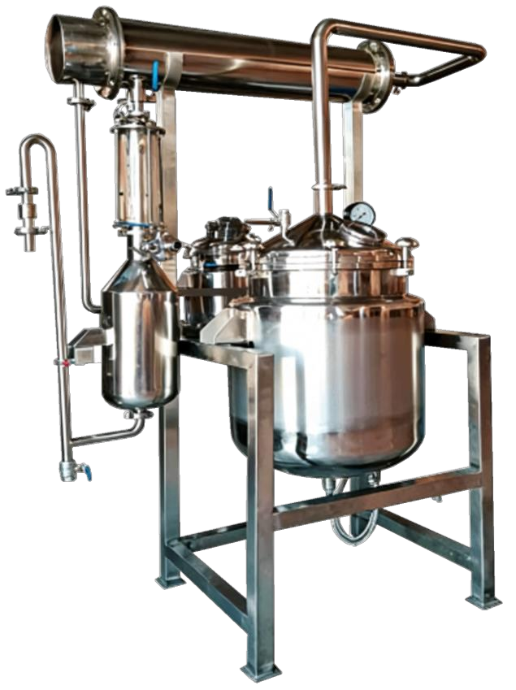

Table of Contents

1: Structural Composition
2: Parameter Table
3: Function and Application
4: Working Principle
5: Operating Procedures
6: Equipment Cleaning
7: Precautions During Operation
8: Equipment Maintenance and Care
9: Transportation and Storage
10: Inspection and Acceptance
11: Warranty Service

Structural Composition:

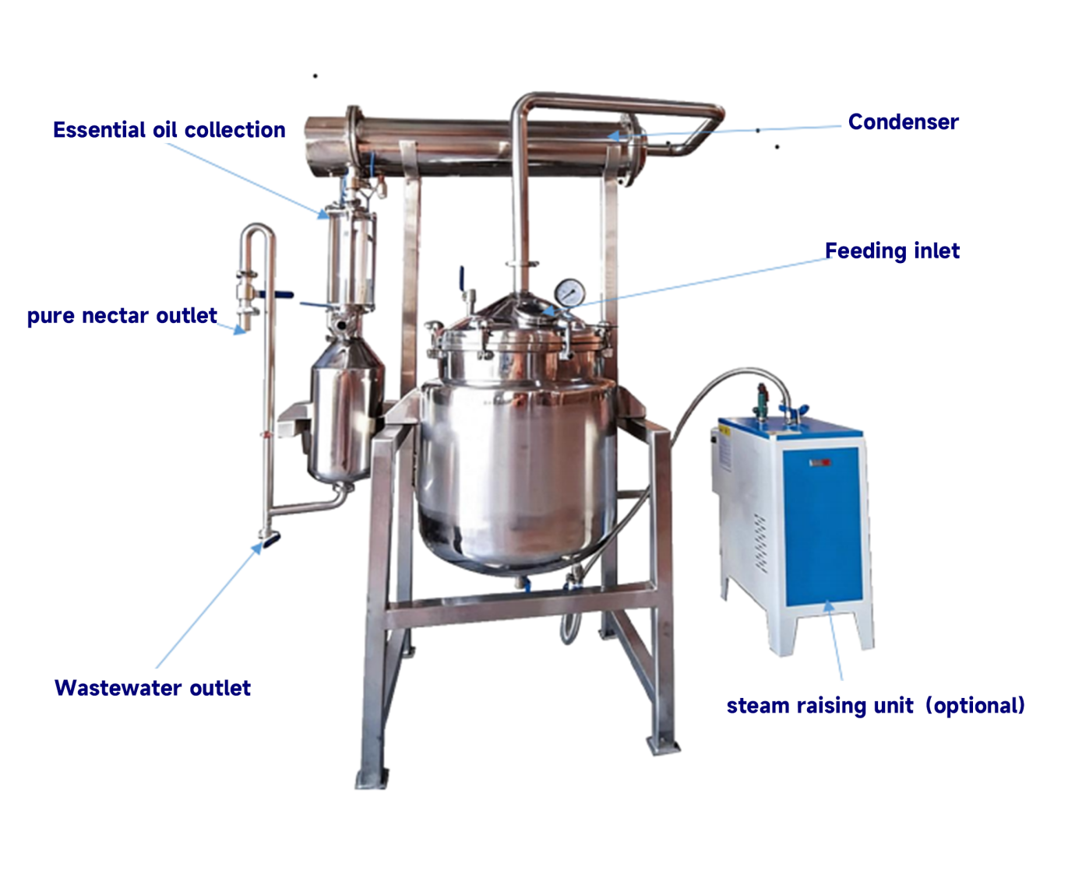

Parameter Table:

Specification | YX-ZL50 | YX-ZL100 | YX-ZL300 | YX-ZL500 | YX-  ZL1000 | YX-  ZL2000
Extraction Tank Volume (L) | 50 | 100 | 300 | 500 | 1000 | 2000
Extraction Tank Inner Diameter (mm) | Φ400 | Φ600 | Φ700 | Φ800 | Φ1000 | Φ1400
Extraction Tank Jacket Diameter (mm) | Φ500 | Φ700 | Φ800 | Φ900 | Φ1100 | Φ1500
Temperature (°C) | 60-100 | 60-100 | 60-100 | 60-100 | 60-100 | 60-100
Steam Consumption (kg/h) | 5 | 10 | 30 | 50 | 100 | 200
Vacuum Pump Power (KW) | 1.1 | 1.5 | 2.2 | 3 | 4 | 4
Electric Heating Power (KW) | 2x3 | 2x6 | 3x6 | 4x6 | 4x9 | 4x12
Cooling Water Consumption (kg/h) | 500 | 500 | 1000 | 1000 | 2000 | 2000
Extraction Time (h) | 0.5-1 | 0.5-1 | 0.5-1 | 0.5-1 | 0.5-1 | 0.5-1
Heat Exchange Area (M²) | 1 | 2 | 6 | 8 | 10 | 15
Diameter x Height (m) | 0.5x1.5 | 0.8x1.6 | 0.9x1.8 | 1.0x1.9 | 1.2x2.5 | 1.6x3.0

Function and Application:
Plant essential oils are aromatic substances extracted from specific parts of plants, such as flowers, leaves, roots, bark, fruits, seeds, resin, etc., obtained through distillation or pressing methods. This machine is suitable for the extraction of essential oils from roses and various other flowering plants using the distillation process. Distillation avoids the long-term exposure of essential oils to high temperatures, preventing destruction, decomposition, hydrolysis, or polymerization, thereby improving both the quality and extraction rate of the essential oils. Steam distillation for essential oil production primarily includes three methods: water distillation, water and steam distillation, and direct steam distillation (steam distillation).

Working Principle:
This equipment uses direct steam heating to recover the solvent and volatile oils. The recovery process involves cooling the vapors through a condenser to reclaim the solvent and volatile oils, achieving high recovery efficiency. Utilizing our company's specialized oil-water separator, made of transparent borosilicate glass, the layering of aromatic oil is clearly visible, making oil collection convenient and straightforward.
Essential Oil Extraction Production Line Equipment Configuration:
The extraction tank features a four-ear hanging support, with the upper head equipped with a quick-opening feeding port. The secondary steam outlet is fitted with a demister. Internally, it has a screen-type filtration device, with the screen supported by a sun disc and punch plate to prevent deformation.
The extraction tank material is stainless steel SUS304, a specialized material suitable for essential oil refining. The total tank volume ranges from 1 to 10 m³, and the tank operates at atmospheric pressure.
Insulation is provided by anti-aging polyethylene foam or high-temperature-resistant polyurethane foam, with an insulation thickness of 50 mm.
Multi-pass shell and tube condenser, cooler, and high-efficiency oil-water separator. The inner walls of the equipment containers are mirror-polished, and the outer surfaces are treated with a mirror or matte finish, meeting GMP and QS certification requirements.

Operating Procedures:
Pre-operational Preparation: Before operation, check if the equipment, valves, and instruments are normal, if the pipelines are clear, and if there are any leaks. Only after confirming no abnormalities, proceed to clean the equipment. Check if the extraction tank is clean. Verify all valves are in the correct open or closed positions. After re-checking and confirming no errors, the equipment can be used.
Start-up: Place the material into the extractor, close the vent valve and outlet valve, open the reflux valve, cooling water, and start the steam generator.
Normal Operation: Steam passes through the material layer, carrying the essential oils out. The essential oil vapor rises through the exhaust pipe to the condenser, then passes through the cooler and oil-water separator, where the essential oil is separated. Collect the essential oil hydrosol, or allow the water to flow back into the extractor for cyclic distillation until all oil is distilled from the material in the extractor.
Shutdown: Stop heating, vent and discharge the residue.

Equipment Cleaning:
1. Cleaning of New Equipment:
After installation of the new equipment, following the above operating procedures, add a 1% caustic soda solution, heat to boil and circulate for 20~30 minutes. Then discharge the caustic soda solution, rinse thoroughly with clean water. Only then can the extraction of the material liquid begin. (Primarily cleans oil stains and impurities from the equipment manufacturing process.)
2. Cleaning for Product Changeover:
Heat and boil a 1% caustic soda solution and circulate for 20~30 minutes. Use a round steel brush to scrub the inner surface of the tank body and the filtration device, then rinse with clean water. Open the feeding port of the evaporator, the reflux elbow pipe of the separator, etc., and rinse these areas with hot water.
3. Daily Shutdown Cleaning:
After daily or batch production, add an appropriate amount of clean water into the equipment, heat and circulate/evaporate for about 20~30 minutes. Stop the equipment, discharge the wastewater, then add clean water again for rinsing. After cleaning, add clean water to a suitable level and shut down the equipment. Before the next operation (the next day or next shift), discharge the clean water from the equipment, then the material liquid can be added for operation.
Precautions During Operation:
1. The extracted material liquid should not be left in the equipment overnight or for extended periods.
2. The liquid level of the material should not be too high.

Equipment Maintenance and Care
1. After each day's work, the equipment should be cleaned thoroughly. Depending on the nature of the material, use different cleaning agents to wash the interior of the equipment.
2. Clean the inner walls of the extraction tank and the filtration device. Use a steel wire brush to remove dirt from hard-to-reach corners of the inner walls. Disassemble and clean the discharge pipe and plug cock. Finally, rinse everything two or three times with clean water.
3. After cleaning, seal all connection points and assemble all parts in order for the next use (ensure the plug cock body and core are matched and installed correctly to prevent leakage).
4. Protect all instruments installed on the equipment; do not damage them arbitrarily, and regularly check their sensitivity and accuracy. If damage or deviation is found, replace or adjust them promptly.
5. Frequently check the sealing condition of all flange and connection joints on the equipment. If sealing gaskets are damaged, replace them immediately.

Transportation and Storage:
1. Hoisting and Transportation
a. The hoisting and transportation of the product shall follow the packaging and transport graphic symbols specified in GB191-1990.
b. Transport using overall wooden crates. Crushing, tilting, or lying flat during transportation is prohibited.
c. During loading and unloading, use the bottom pallet as the lifting point. Do not lift or fork from one side to avoid imbalance and tilting.
2. Storage Conditions
a. Packaged goods should be stored promptly indoors in a well-ventilated, dry, and non-humid environment.
b. When placing the packaging boxes, ensure the text markings on the boxes face outward for easy observation.
c. If equipment must be stored outdoors, take effective waterproof, rainproof, and temperature control measures to ensure equipment safety and protection.

Inspection and Acceptance:
Within 15 days after the equipment arrives at the user's site, open the packaging for inspection. Notify the manufacturer seven days before the inspection date. Both parties shall jointly inventory and inspect the goods and sign a detailed unpacking inspection report.
Warranty Service:
Provided the user adheres to the rules for storage, use, installation, and transportation, the manufacturer will provide free repair or replacement of parts for damage or malfunction occurring within one year from the date the goods arrive at the port, if caused by manufacturing defects.
For faults or damages caused by improper use or human factors, adhering to the principle of serving the user, the manufacturer can assist in repairing the product, charging only appropriate cost fees. After the warranty period, the company can still provide various spare parts for the user in the long term, offering lifetime service. If there are any product quality issues, or if the user has valuable suggestions for product improvement, please contact the company's after-sales service center directly and provide timely feedback to help us improve in the future.

